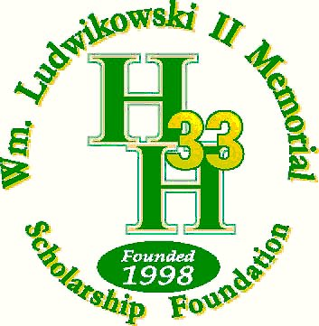

This will be the 28th annual William Ludwikowski Memorial Scholarship Golf Tournament. The O.W. Holmes Class of 1977 continues our mission to provide opportunities for education to future Holmes Alumni. Your contributions are essential to supporting our Foundation. I invite you to view our website at [www.wl33foundation.org](http://www.wl33foundation.org) for more detailed information.

Briefly, I should tell you that Bill was our classmate at Holmes and an outstanding scholar, athlete, and leader of our peers. He died of cancer about ten minutes after receiving his diploma on graduation day in May 1977. He had received numerous scholarships and was set to attend Princeton University after high school. After his untimely death, our classmates, and teammates set up an educational fund to honor Bill and his parents by raising money and granting scholarships in his name. The response over the years has been tremendous.

This annual golf tournament is our only fundraiser. Thanks to the support of former classmates, friends in the community, and businesses, we have helped provide scholarships to many young people who desire to further their education. To date, we have provided 80 scholarships totaling more than $355,000 to Holmes High School Graduates.

This year we are set to hold our golf tournament at Silverhorn Golf Club on Saturday, July 12th, 2025, please consider partnering with us with a donation of money, a gift, or a gift certificate. Contact me as soon as possible to collect your donation. I am honored by your support and grateful for your participation.

Sincerely,

Paul J. Kuwamura Tax ID # 74-3007732

Chairman 501 (c) (3) exempt

[paulkuwamura@yahoo.com](mailto:paulkuwamura@yahoo.com)

210-383-3395